# **People element recap**

* What are some challenges in leading a project team? **Answer**: Multiple reporting lines, reliance on ability to influence and motivate, competing priorities, and hierarchical tension.
* How can we define the term ‘stakeholder’? **Answer**: A stakeholder is any individual or organization that can affect or be affected by an initiative.
* How would you describe culture? **Answer**: Culture is the set of shared attitudes, values, goals, and ways of working that characterize a group of people.
* What is the purpose of the change management approach? **Answer**: to establish the target organizational state required for the project to meet its objectives together with the means by which the business will shift from the current state and through any interim states.
* Why is a clear approach to communication important for a project? **Answer**: It helps to avoid unnecessary barriers in implementing any changes, as people seek to protect the current situation or to limit the perceived negative impact of the project.

# **Organizing practice recap**

* What is the purpose of the organizing practice? **Answer**: To define and establish the project’s structure of accountability and responsibilities.
* What are the roles (and their responsibilities) in the project management team? **Answer**: Project executive, senior user, senior supplier, project manager, team manager, project assurance and project support.
* What are the three project interests? **Answer**: Business, user, and supplier.
* Why is it important to have a work breakdown structure? **Answer**: It supports the project manager in structuring teams and setting boundaries
* What should you include when designing the project ecosystem? **Answer**: Project team structure, people and resources required, working practices, behaviours, and culture.

1. **Understand organizational ecosystem** This is necessary to successfully design the project organization and determine how the project ecosystem will develop as a distinct entity from the organizational ecosystem, with alignment and an effective interface where required.
2. **Design project ecosystem** Organizing work and people to achieve the project’s objectives includes determining the project team structure, people and resources required, working practices, behaviours and culture.
3. **Develop the project ecosystem** Involves implementing the project organizational design and adapting it as the project progresses in response to changing project needs, team members and relationships.
4. **Manage changes to project ecosystem** It is critical to have clear feedback loops established to determine whether there are any capability or capacity gaps or relational issues to address.
5. **Transition project into organizational ecosystem** As at the start, it is important to understand the organizational ecosystem that the project products and people will be transitioning into at the close of the project and to incorporate lessons learned.

# **Business case recap**

* **Purpose**: the purpose of the business case practice is to establish mechanisms to judge whether a project is (and remains) desirable, viable, and achievable.

**Define and give examples of the following key concepts:**

* **Output**: this is the product delivered by the project. In the scenario, the output is the new campaign. Can learners think of what the output would be in their own work/previous experience?
* **Outcome**: this is what the user can do with the output. In the scenario, the outcome would be increased awareness of discrimination against marginalized groups. Are there other examples the group can think of, perhaps in relation to the outputs they suggested?
* **Benefit**: these are the measurable improvements of using this product. In terms of a campaign project, this may be linked to an increase in donations or applications to volunteer with the charity. Encourage the learners to continue to consider it through their own experience.
* **Dis-benefit**: this is the opposite of an improvement. In the context of the workshop scenario, this could be a decline in donations to other campaigns run by the same charity.

# **Supporting techniques for the business case**

An **investment appraisal** compares the costs of developing, operating, and maintaining the project product with the value of the benefits over a period of time. The investment appraisal looks at the relationship between benefits, costs, and risks. It should cover both the project costs (both in producing the required products and the project management costs) and the ongoing operations and maintenance costs.

**Multi-case model**:

Evaluating investments from different perspectives, rather than focusing solely on financial return, gives a rounded view of whether an investment is desirable, viable, and achievable.

* **Strategic** perspective understanding the drivers for change and demonstrating how the investment provides strategic fit
* **Economic** perspective identifying the option that delivers best value, including wider social, environmental, and sustainability considerations
* **Implementation** and commercial perspective showing that the preferred option can be delivered by service providers and that robust arrangements are established for successful project delivery.

**RACI**

**A/R1:** Business is accountable for the appointment of the project executive and the project manager. They are also responsible for appointing the project executive.

**C2/I2**: If any team managers have been identified when designing and appointing the project management team, then it is good practice to consult them on the project approach and inform them of key details in the stage plan for the initiation stage should they be involved in that stage.

**C3**: The senior user or senior supplier will consult on the prepare the outline business case activity if/when appointed.

# **Directing a project recap**

* **Directing a project’s purpose**: enable the project board to be accountable for project success.
* **Directing a project’s activities**:
  + - authorize initiation
    - authorize the project
    - authorize a stage or exception plan
    - give ad hoc direction
    - authorize project closure.

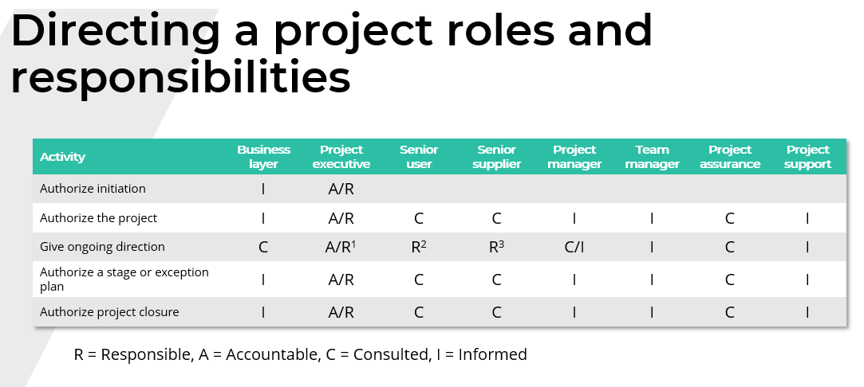

R1: Business related

R2: User related

R3: Supplier related

# **Initiating a project recap**

* **Initiating a project’s purpose**: to establish a solid project baseline and assure a common understanding of all aspects of the proposed project.
* Initiating a project’s **activities**:

1. agree tailoring requirements
2. prepare the risk management approach
3. prepare the change control approach
4. prepare the quality management approach
5. prepare the communication management approach
6. set up the project controls
7. create the project plan
8. prepare the benefits management approach
9. assemble the project initiation documentation.

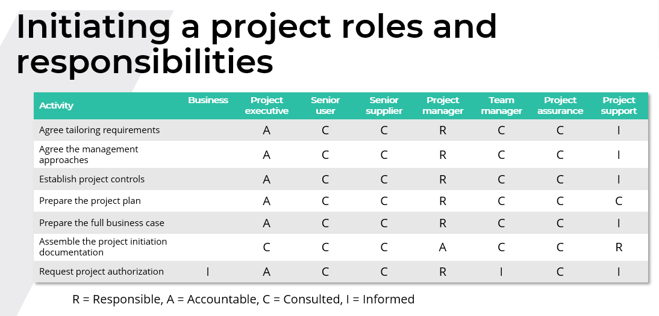

# **Plans practice recap**

* **Purpose**: to facilitate communication and control by defining the means of delivering the products.
* Questions answered by defining the means of delivering the products: **where, how, by whom, when, how much?**
* **Definition of a plan**: a detailed proposal to enable the project team to understand products, risks, issues, people/resources, activities, and targets/tolerances.
* **Four types of plan**: project plan, stage plan, team plan, exception plan.

# **Quality practice recap**

**• Purpose: to define and implement the means by which the project will verify that products are fit for purpose.**

**• Terms:**

1. **Quality**: the degree to which a set of inherent characteristics of a product, service, process, person, organization, system, or resource fulfils requirements.
2. **Quality management**: the coordinated activities to direct and control an organization with regard to quality.
3. **User’s quality expectations**: a statement on the quality expected from the project product, captured in the project product description.
4. **Acceptance criteria**: a prioritized list of criteria that the project product must meet before the customer will accept it.
5. **Quality specifications**: a description of the quality measures that will be applied by those performing quality control and the levels that a finished product must meet.

* **Verification**: focuses on confirming that the interim products (such as the project design) reflect the necessary quality specifications and acceptance criteria and on ensuring that the delivery method follows good practices
* **Validation**: focuses on confirming that the product meets the quality specifications and acceptance criteria
* **Prototyping**: produces an interim product that is used to obtain early feedback on its functionality or to understand full scale production concerns and is integral to an iterative-incremental delivery method such as Agile; sometimes referred to as beta testing
* **Testing**: involves the use of the product, its components, or some portion of its functionality under conditions representative of its intended use
* **Inspection**: confirms that the product complies with quality specifications and acceptance criteria and is most applicable to commodities and commercial off-the-shelf products.
* **Certification**: presentation of proof that the product or supplier complies with applicable industry or regulatory requirements and is only applicable to commercial off-the-shelf products.
* The purpose of a **product description** is to describe a product’s purpose, composition, derivation, and quality specifications. It is produced at the planning phase as soon as possible after the need for the product is identified.
* The purpose of the **quality management approach** is to describe the quality techniques and standards to be applied and the roles and responsibilities for achieving the required quality specifications and acceptance criteria during a project.
* The purpose of the **quality register** is to summarize all quality management activities that are planned or have occurred. The quality register is used by the project manager and project assurance as part of reviewing progress.
* The purpose of the **product register** is to list of all products required of a plan and the status of those products.

Start from RISK